User Mannual

Access chat bot page

<https://www.facebook.com/Chatbot-demo-Sheahta-Ibrahim-353709562137172/>

start messaging with it (say hi for example)

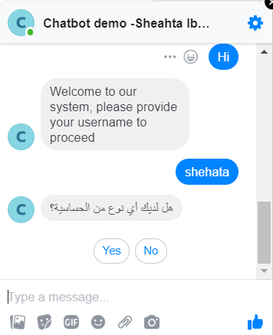

Enter your user name defined in the system (amer , shehata)

The survey will start with mostly yes/no questions with the language set in the user preferences (Getting user locale from facebook requires a proof of business need which is not yet available)

In case of shehata it is Arabic

In case of amer it is French

Once done you will receive a success message



After being done with the survey you can log into doctors UI by accessing

<http://refugees.i4.io/>

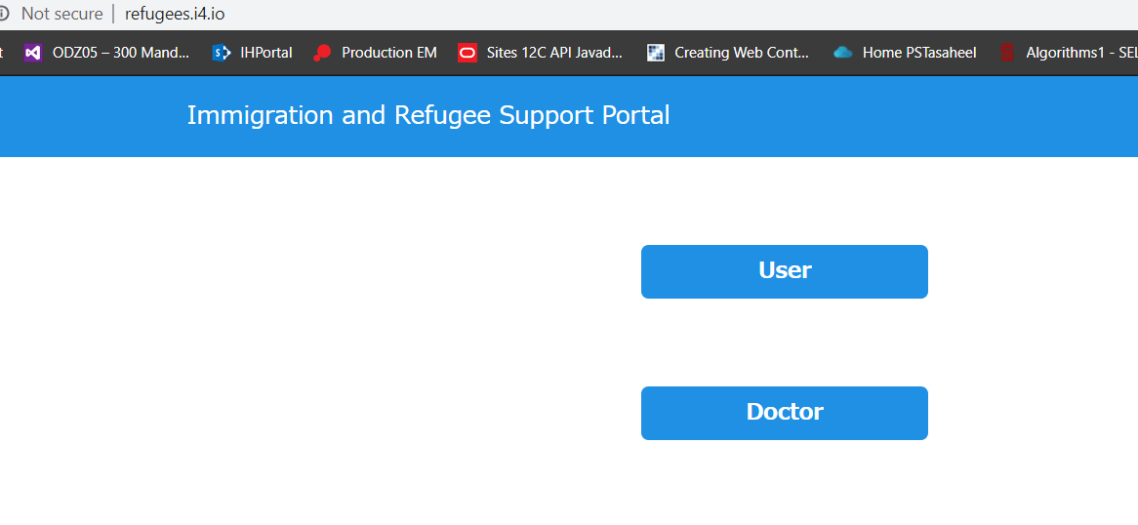

then select doctor

doctor name is: doctor-en

password: consultya

the list of users who had completed the survey will be listed

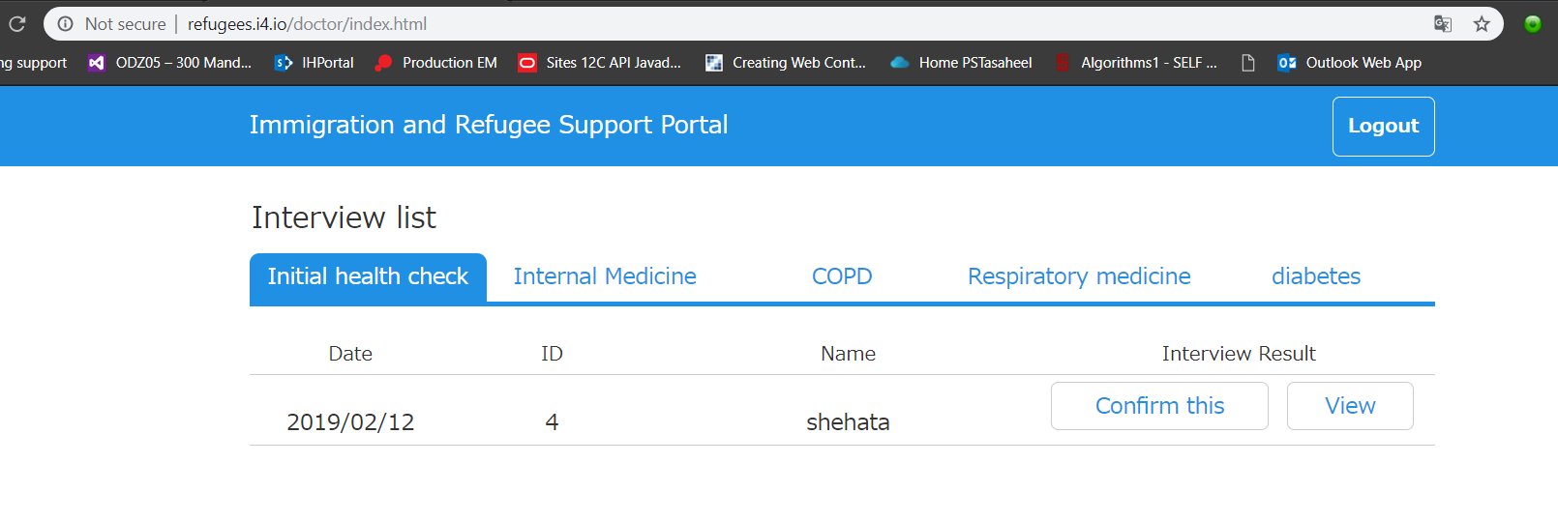

If you click view the user screening data will be displayed

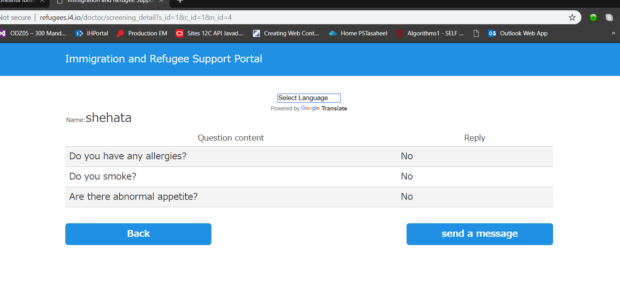

The doctor can message the patient using the send message button and this will send the message to his facebook messenger

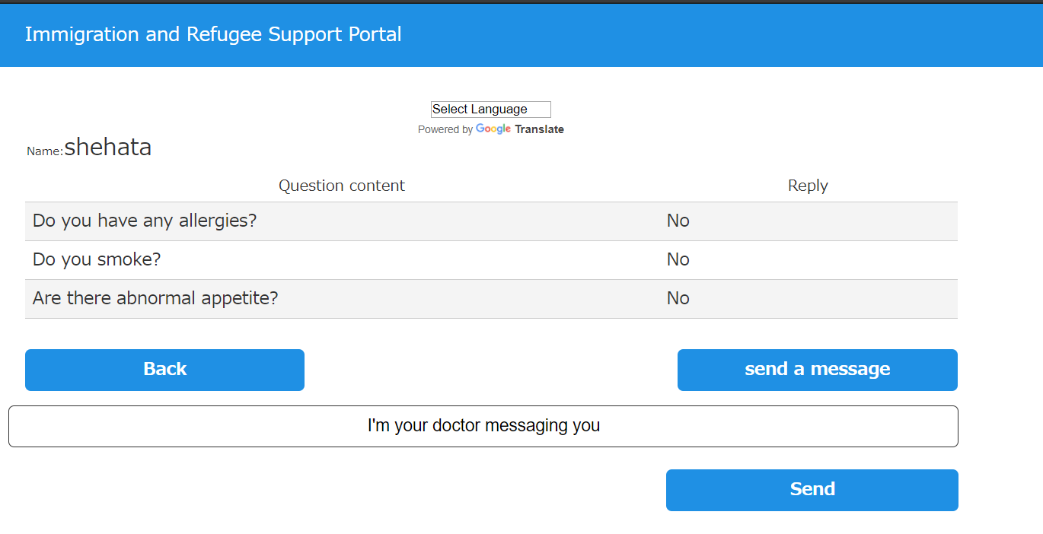

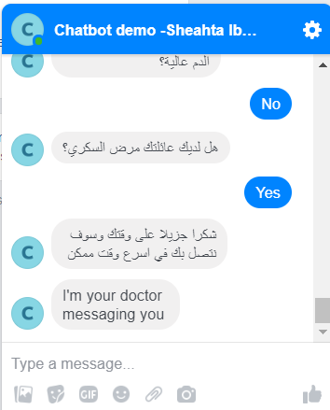

And if the doctor wants to confirm the screening data just click confirm